**Power transform (Box-cox transform):**

As we know that we can convert log normal distribution by doing the natural log of each observation, and then we can apply all mathematics theory of Gaussian distribution.

Now the question is how to convert **Pareto distribution** to **normal distribution.**

For this conversion we use box-cox transform.

The box cox transform basically is a method to find the **lambda** value which when use in the way we gave the formula **(x^lmbda - 1)/lambda** will result in a distribution which will be a **gaussian distributed variable**. That means we can achieve a gaussian distributed random variable from Paretto distribution if **lambda is finite and non zero**. Now if **lambda is zero** it will say that **log(x)** will follow gaussian distribution, which means that **x is a log normal distribution** which gave lambda =0.

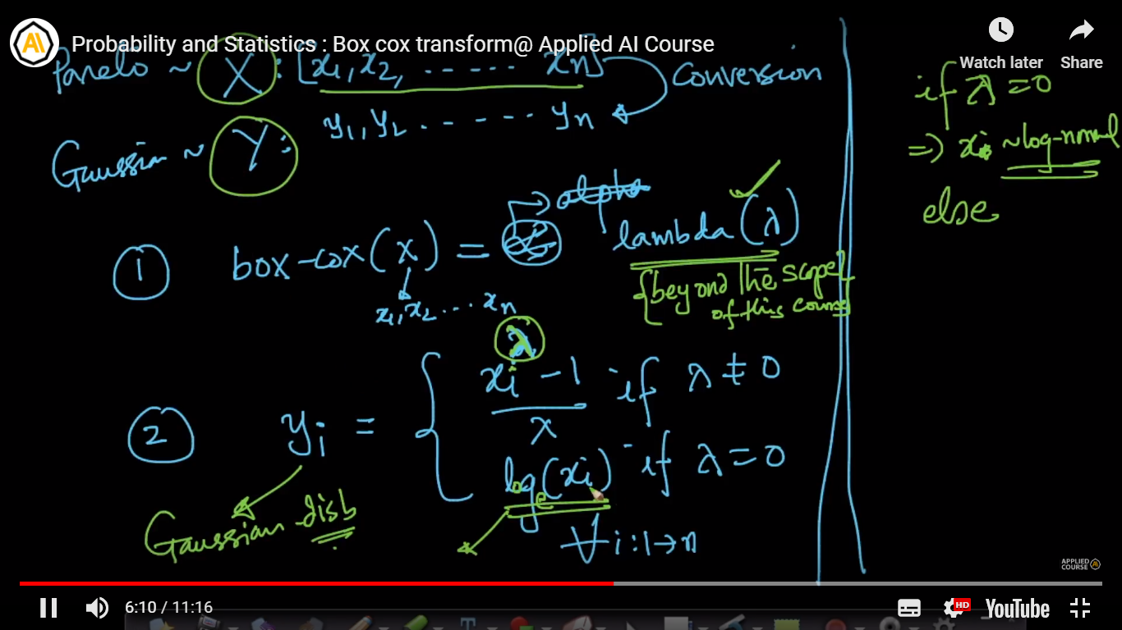

We can use scipy to find box-cox, which will the return the converted array which is gaussian distributed.

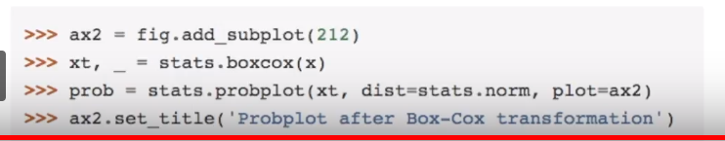

**Note:** Box-cox transform is not guaranteed to work on all Pareto or power-law distributed data. It works only on some of them and we need to perform the box-cox transform and observe the QQ-plot to be certain of it working well on our data.